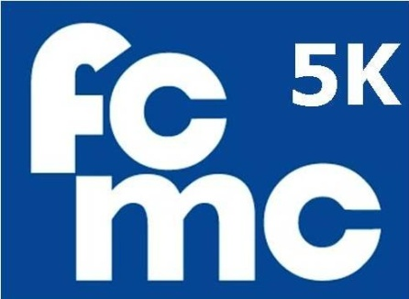

Here is what you will need for the 2012 5K the FCMC Way Training Program.
Print off what you need:
- Program Explanation
- Walking program schedule for May
- Walking program schedule for June
- Walk/Jog program schedule for May
- Walk/Jog program schedule for June
- Run program schedule for May
- Run program schedule for June
- Saturday Group Walk/Run Instructions
- Week 1 Activity Sheet
- Week 2 Activity Sheet
- Week 3 Activity Sheet
- Week 4 Activity Sheet
- Week 5 Activity Sheet
- Week 6 Activity Sheet
- Week 7 Activity Sheet
- Charley Western Firecracker 5K registration Form -July 4th
- Water Over the Dam Days 5K - Nashua
- Creating Wellness Center Exercise Program
- Curves – 90 Day Program
- Curves - Zumba
- Walking Map



